PROFILE ANDRÉ LÜTZKENDORF

PERSON & CONTACT

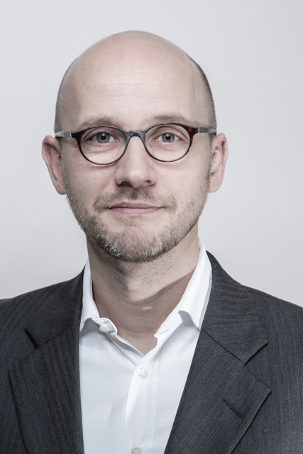

name André Lützkendorf
year of birth 1972
nationality german

address Tattenbachstrasse 1
80538 Munich
Germany

telephone +49 172 8 05 41 65

email info@luetzkendorf.eu
www www.luetzkendorf.eu

EDUCATION

Study of mathematics degree as Dipl. Mathematiker (FH)

at the University of Applied Sciences Mittweida

Languages german (mother tongue)

english

PROJECT LIST

Mar. 2020 – now Telekommunikation, München
Building a data warehouse for b2b
- requirements analysis
- process documentation
- realisation

May. 2019 – Feb. 2020 Sabbatical

Jul. 2016 – Apr. 2019 Media, Munich
Building a data warehouse
- DWH design
- process documentation/ confluence
- requirements analysis
- technical specification/ confluence
- test concept and testing/ jira
- prototyping: reporting based on the CRM system
- prototyping: revenue reporting
- supporting migration of a CRM system

Jul. 2016 – Mar. 2019 Telecommunication, Munich
Consolidation of data warehouses
Due to the merger of several companies, the locally existing DWHs has to be integrated into one global model.
Offshore-Project
- requirements analysis
- specification/ confluence
- test concept and testing/ jira

Jul. 2014 – Jun. 2016 Telecommunication, Munich
Optimization of management reporting
- requirements analysis
- specification/ confluence
- support ETL development
- test concept and testing/ jira

Dec. 2012 – Apr. 2014 Cable network provider, Munich
Project order tracking,
Orders will be reported consistently beginning from their order entry to their realization or termination.
Integration of 4 source systems.
Nearshore-Project
- project management
- business analysis, technical concept
- definition of kpi
- adapt model of reporting requirements
- feasibility study, prototyping
- support for development

Sep. 2012 – Nov. 2012 Cable network provider, Munich
Consulting product portfolio/ strategy
- Pre-analysis, cost-benefit assessment of new projects
- strategic consultancy

Jul. 2009 – Aug. 2012 Cable network provider, Munich
Project Subscriber,
Reporting system for management, sales, product management, controlling, technical operations,
Integration of 4 source systems and various unstructured data
- business analysis
- coordination stakeholder to define kpi and dimensionalities
- design datamart (ERwin)
- specification ETL
- test concept & testing
- reporting

Jan. 2009 – Mar. 2009 Cable network provider, Munich
Project Subscriber,
Pre-analysis
- stakeholder analysis
- process analysis
- kpi model
- design datamart (ERwin)

Jun. 2008 – Dec. 2008 Logistic, Frankfurt am Main
Project KSP,
Reporting system for ressource planning
- business concept
- projectmanagement

Jul. 2008 Automotive supplier, Munich
Review of the first DWH project
- review of the first results,
consulting in data modelling,
demonstration of potentials in universe design
- Prototyping: reporting in SAP BO

Sep. 2007 Internet sales portal, Dresden
Review of the first DWH project
- review of the first results,
consulting in data modelling,
identification of errors and potentials in universe design
- reporting in WebI
- creation of a user concept

May 2007 – Sep. 2007 Telecommunication, Munich
Project Galileo,
Redesign of ETL processes due to the version change of the billing system
- (Details auf Nachfrage)

Dec. 2005 – Apr. 2007 Telecommunication, Munich
Global modelling of network costs
- (details on request)

Jan. 2004 – Nov. 2005 Media, Köln
Project RAMON,
Reporting system for media analyses
- (details on request)

Aug. 2002 - Jun. 2003 Telecommunication UMTS network, Hamburg
Conception of a data warehouse to support the construction of the UMTS network
- (details on request)

Jul. 2000 - Jul. 2002 Telecommunication ServiceProvider, Hamburg
Establish an enterprise-wide data warehouse for the customer area with Informatica PowerMart, Business Objects, Mis Alea, and Hyperion
- (details on request)

Jan. 1999 – Jun. 2000 Insurance, Munich
Integration of the molap products Mis Alea, Importmaster and InterfaceBuilder into the existing system environment
- (details on request)

PRODUCTS

Databases | - Oracle  - MySql  - PostgreSql  - Teradata  - Sybase ASE, Sybase IQ
SQL query | - Toad  - SQL Developer
BI tools | - SAP Business Objects (IDT, WebI)  - Tableau
other | - Jira  - Confluence  - erWin

REFERENCES

Sep. 2012 – Dec. 2014 Cable network provider, Munich
[...] I have come to appreciate you as a very competent, technically very experienced employee. Your goal-oriented way of working, your very good perceptiveness coupled with the very good understanding in dealing with specialist areas and their concerns results in a combination that has enabled me to use you very successfully in a wide variety of tasks. You have always been goal- and result-oriented in the tasks assigned to you and have been able to maintain a very good balance in many parallel activities.
In summary, I would like to mention that as a consultant you have established yourself as a very central person and contact person over the last few years due to your friendly nature, your competencies and your independent way of working. [...]

Jan. 2009 – Aug. 2012 Cable network provider, Munich
[...] Mr. Lützkendorf was a very well qualified consultant, who quickly and confidently familiarized himself with his new field of expertise due to his above-average perceptiveness. [...] He has a very high level of self-motivation, very good self-management and was therefore able to successfully master additional tasks at any time thanks to his professional, planned approach. [...] He was an open-minded and team-oriented consultant who always played an active and successful role in integrating new colleagues into the project team. [...]

Jan. 2004 – Nov. 2005 Media, Köln
[...]Mr. Lützkendorf has, with a lot of commitment and know how, contributed significantly to the analysis and redesign of the isolated existing reporting system and its integration into the data warehouse. [...]The variety of these tasks required a high level of technical quality in the implementation. [...]Mr. Lützkendorf applied his expertise in Business Intelligence continuously and with great success. The work was always characterised by care and accuracy. He proved to be a committed, reliable and extremely pleasant member of our project team. [...]

Aug. 2002 - Jun. 2003 Telecommunication, Hamburg
[...] Mr. Lützkendorf always worked absolutely safely and completely independently. [...] Even in difficult situations one could always rely on him. Mr. Lützkendorf was always extremely adaptable, versatile and open-minded and interested in everything new. We were extremely satisfied with his performance at all times. The cooperation with Mr. Lützkendorf was extremely pleasant both personally and professionally. [...]

Jul. 2000 - Jul. 2002 Telecommunication, Hamburg
[...] Mr. Lützkendorf always worked absolutely safely and fully.
come independently. [...] Even in difficult situations
you could always rely on him. Mr. Lützkendorf was always extremely adaptable, versatile and open-minded and interested in everything new. We were extremely satisfied with his performance at all times. The cooperation with Mr. Lützkendorf was extremely pleasant both personally and professionally. [...]

Jan. 1999 – Jun. 2000 Insurance, Munich
[...] Mr. Lützkendorf was characterized by a very precise, goal-oriented way of working. He quickly familiarized himself with the new OLAP topics and technologies and thus became a competent consultant for the entire subject area of 'reporting'. The customers for whom Mr. Lützkendorf worked were very satisfied with his competence and commitment. [...]

